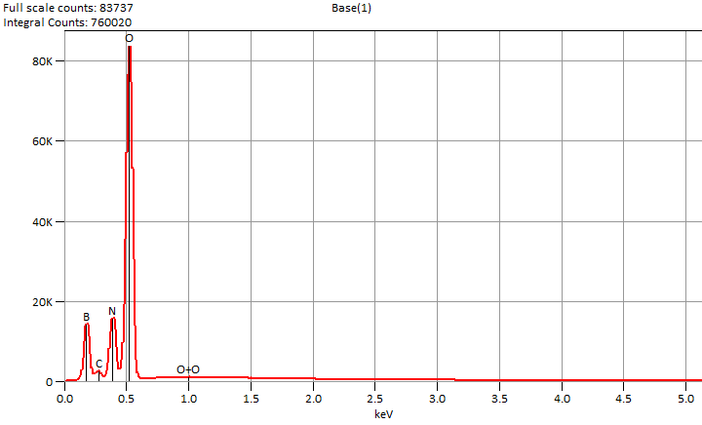

Live Time: 60.0 sec.

Tue Dec 10 11:24:33 2024

Filter Fit Chi Squared:297.140

Errors: +/- 1 Sigma

Correction Method: Proza (Phi-Rho-Z)

Acc.Voltage: 5.0 kV Take Off Angle: 33.5 deg.

Detector: UltraDry

WDS Results Unavailable for: Base(1)

|  |
| --- |
|  |

Quantitative Results for: Base(1)

|  |  |  |  |  |  |  |
| --- | --- | --- | --- | --- | --- | --- |
| ***Element***  ***Line*** | ***Int.***  ***Cps/nA*** | ***Int.***  ***Error*** | ***Weight %*** | ***Weight %***  ***Error*** | ***Atom %*** | ***Atom %***  ***Error*** |
| ***B K*** | 158.88 | ± 1.87 | 8.7 | ± 0.1 | 12.1 | ± 0.1 |
| ***C K*** | 29.23 | ± 2.63 | 0.9 | ± 0.1 | 1.2 | ± 0.1 |
| ***N K*** | 162.70 | ± 2.27 | 11.9 | ± 0.2 | 12.8 | ± 0.2 |
| ***O K*** | 1151.5 | ± 5.67 | 78.4 | ± 0.4 | 73.9 | ± 0.4 |
| ***Total*** |  |  | 100.0 |  | 100.0 |  |

ROI Results for: Base(1)

|  |  |  |
| --- | --- | --- |
| ***Operation*** | ***Gross Counts*** | ***Net Counts*** |